Ideation Phase Empathize & Discover

|  |  |
| --- | --- |
| Team ID | PNT2022TMID10050 |
| Project Name | PERSONAL ASSISTANTANCE FOR SENIORS WHO ARE SELF-RELIANT |
| Maximum Marks | 4 Marks |

**Empathy Map Canvas:**

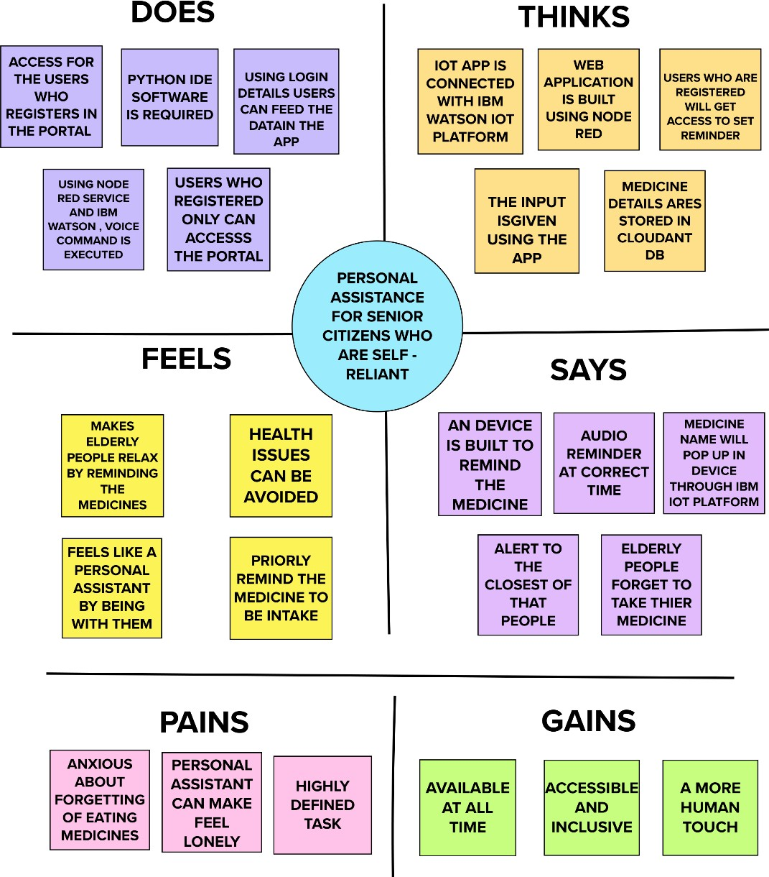

Reference:[https://app.mural.co/invitation/mural/balamurugansam45gmailcom1469/16659](https://app.mural.co/invitation/mural/balamurugansam45gmailcom1469/1665924809930?sender=u7ee4ef2bc8279c756ef56351&key=3436ad58-a40e-499a-9302-b560aa568c7f) [24809930?sender=u7ee4ef2bc8279c756ef56351&key=3436ad58-a40e-499a-9302-](https://app.mural.co/invitation/mural/balamurugansam45gmailcom1469/1665924809930?sender=u7ee4ef2bc8279c756ef56351&key=3436ad58-a40e-499a-9302-b560aa568c7f) [b560aa568c7f](https://app.mural.co/invitation/mural/balamurugansam45gmailcom1469/1665924809930?sender=u7ee4ef2bc8279c756ef56351&key=3436ad58-a40e-499a-9302-b560aa568c7f)